**Unit 9: Charts Worksheet and Analysis**

**Exercise 9.1**

*Q: Open the Excel workbook in Exa 9.1D.xlsx from the Exercises folder. This contains the percentage frequencies together with the bar chart just created in the above example. Add a percentage frequency bar chart showing the brand preferences in Area 2, using the same format as that employed for the Area1 results in the above example. Drag your new chart so that it lies alongside that for Area 1. Briefly interpret your findings. What do these results tell you about the patterns of brand preferences for each of the two demographic areas?*

A: We can see from the chart of Area 1 that the respondents prefer Other Brands of cereal compared to Brand A and Brand B. However a higher percentage of them prefer Brand B to Brand A. Comparing the preferences of Area 2, we can see that a high percentage of respondents also prefer Brand B compared to Brand A. However, while most of the respondents also preferred Other Brands , we can see that the percentage of respondents who prefer Other Brands is much higher in Area 1 than in Area 2.

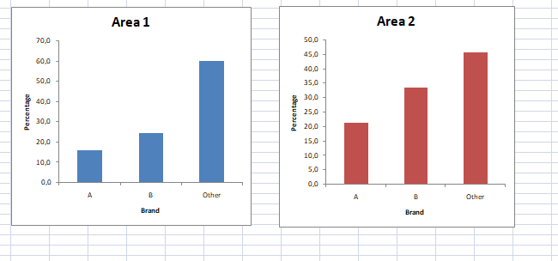

**Exercise 9.2**

Q: Open the Excel workbook in Exa 9.2E.xlsx from the Exercises folder. This contains the frequency distributions for Data Set E (see the Data Annexe) to which has been added the corresponding percentage frequency distributions. Complete a percentage frequency clustered column bar chart showing the heather species prevalence in the two different locations. Briefly interpret your findings.

A: We can determine from the chart that the species of heather is more abundant in Location A compared to Location B, and it is also more sparse in Location B than in Location A.

